Church Walk Primary School DT Scheme of Work
Hoad Cycle Year 2 Cycle A |  |  |  | Key Assessment Criteria
 | Autumn | Spring | Summer
Focus | Fabric : weaving  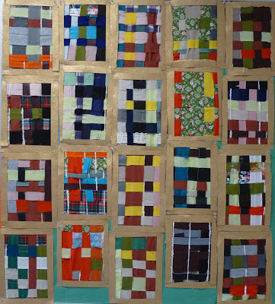  Weave the wizard a new pocket | Kites (Plan Bee Unit)  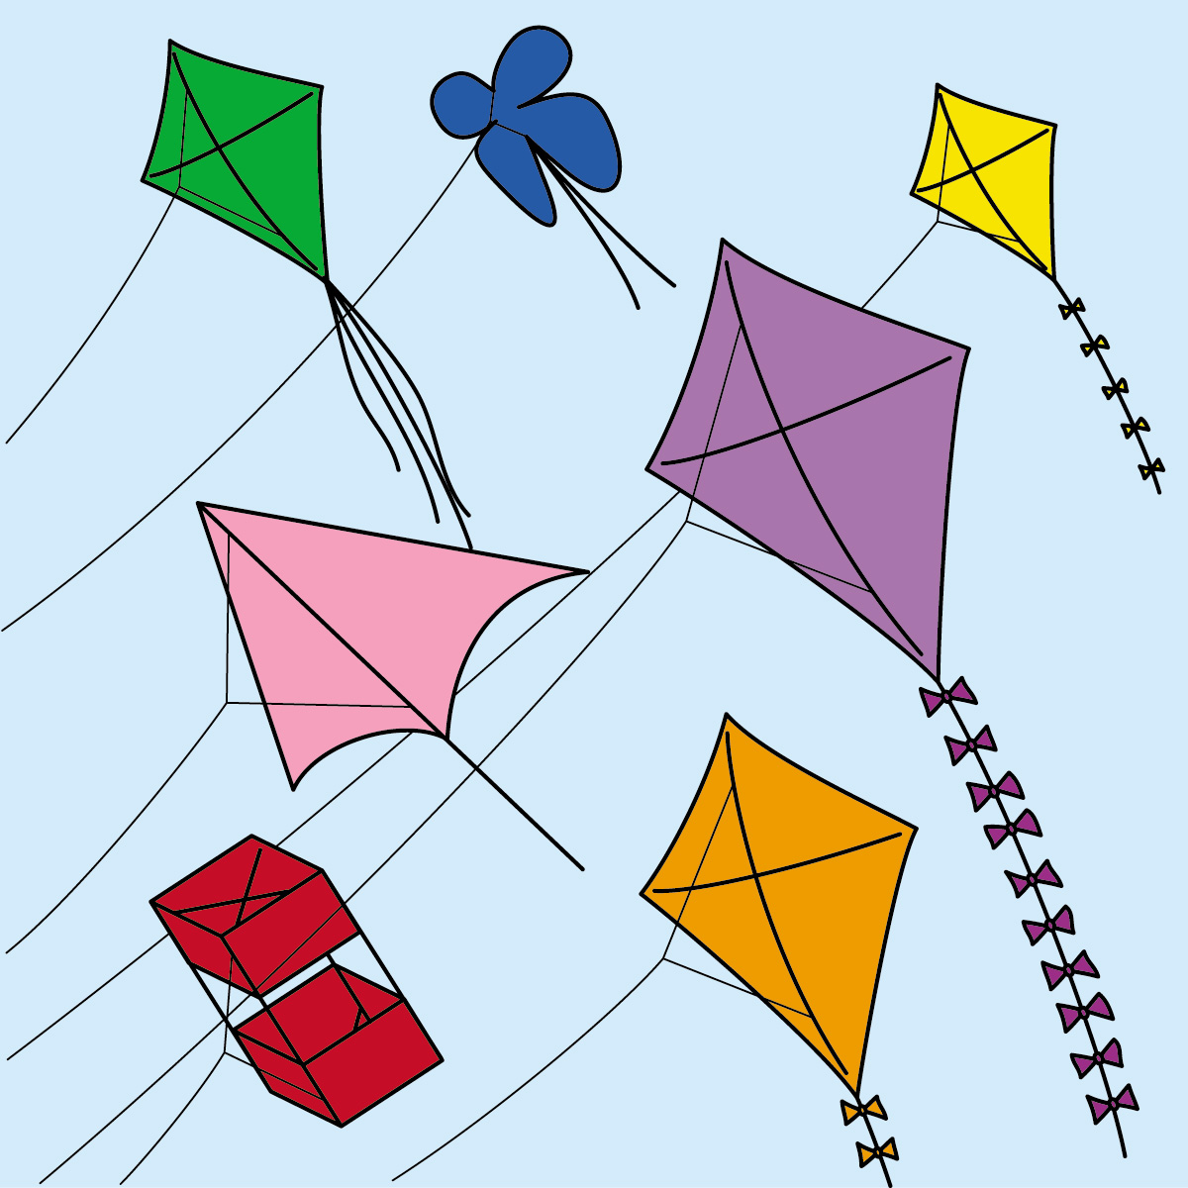 | 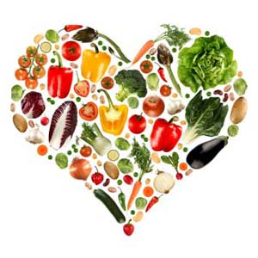  Healthy Eating / Food Hygiene  Rainbow Pizzas  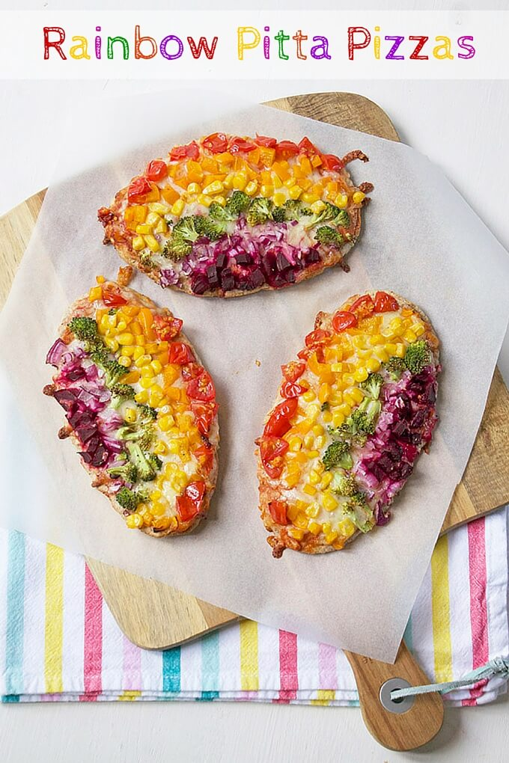 | - I think of an idea and plan what to do next  - I choose tools and materials and explain why I have chosen them  - I join materials and components in different ways  - I explain what went well with my work  - I explain why I have chosen specific textiles  - I measure materials to use in a model or structure  - I describe the ingredients I am using
Resources | -strips of assorted fabrics  - cereal boxes for looms  - yard for looms  - staplers to secure finished product | Powerpoint slides of different kites from around the world  - dowels, kebab skewers, tissue paper, wrapping paper, string, foil, plastic bags  - string, poles (Japanese carp kites) | -range of fruit and vegetables( including more unusual ones)  - plates, dishes, peelers, mixing bowls  - plastic table covers, aprons, access to kitchen / handwashing facilities  - non-fiction books about healthy eating, fruit, vegetables  - fiction books e.g. Oliver’s Vegetables, Growing Good
Curriculum links | Literacy: 10 Things Found in a Wizard’s Pocket Poem  Maths: measuring strips of fabric; lengths of string to make simple looms | Maths- measurement of different materials  Literacy- labelling, captions, explanations, evaluations | Science- healthy eating and lifestyles; heating and colling of pizza ingredients  Maths-weighing and measuring
Skills | Design a useful and appealing pocket for the Wizard  Using textiles with a variety of colours / textures  Simple weaving (understanding warp and weft)  Simple sewing skills (running stitch)to attach completed pocket to fabric  Evaluation –of product and skills | Evaluate kites from different countries (designs and purpose)  Explore different materials for kite construction. Prediction and testing of kite designs  Use templates to make a Japanese carp kite; diamond kite  Cutting , sticking and attaching to strinds and poles.  Using ‘I will…….’ statements in planning process  Evaluating finished products and processes on own, and other’s work | Being aware of healthy eating and food hygiene  Making a ‘mock up’ on paper to use as a design template  Know properties of food- taste, texture and appearance  Preparing and combining ingredients into specific projects  Using basic tools safely  Evaluating finished products and process in more detail

